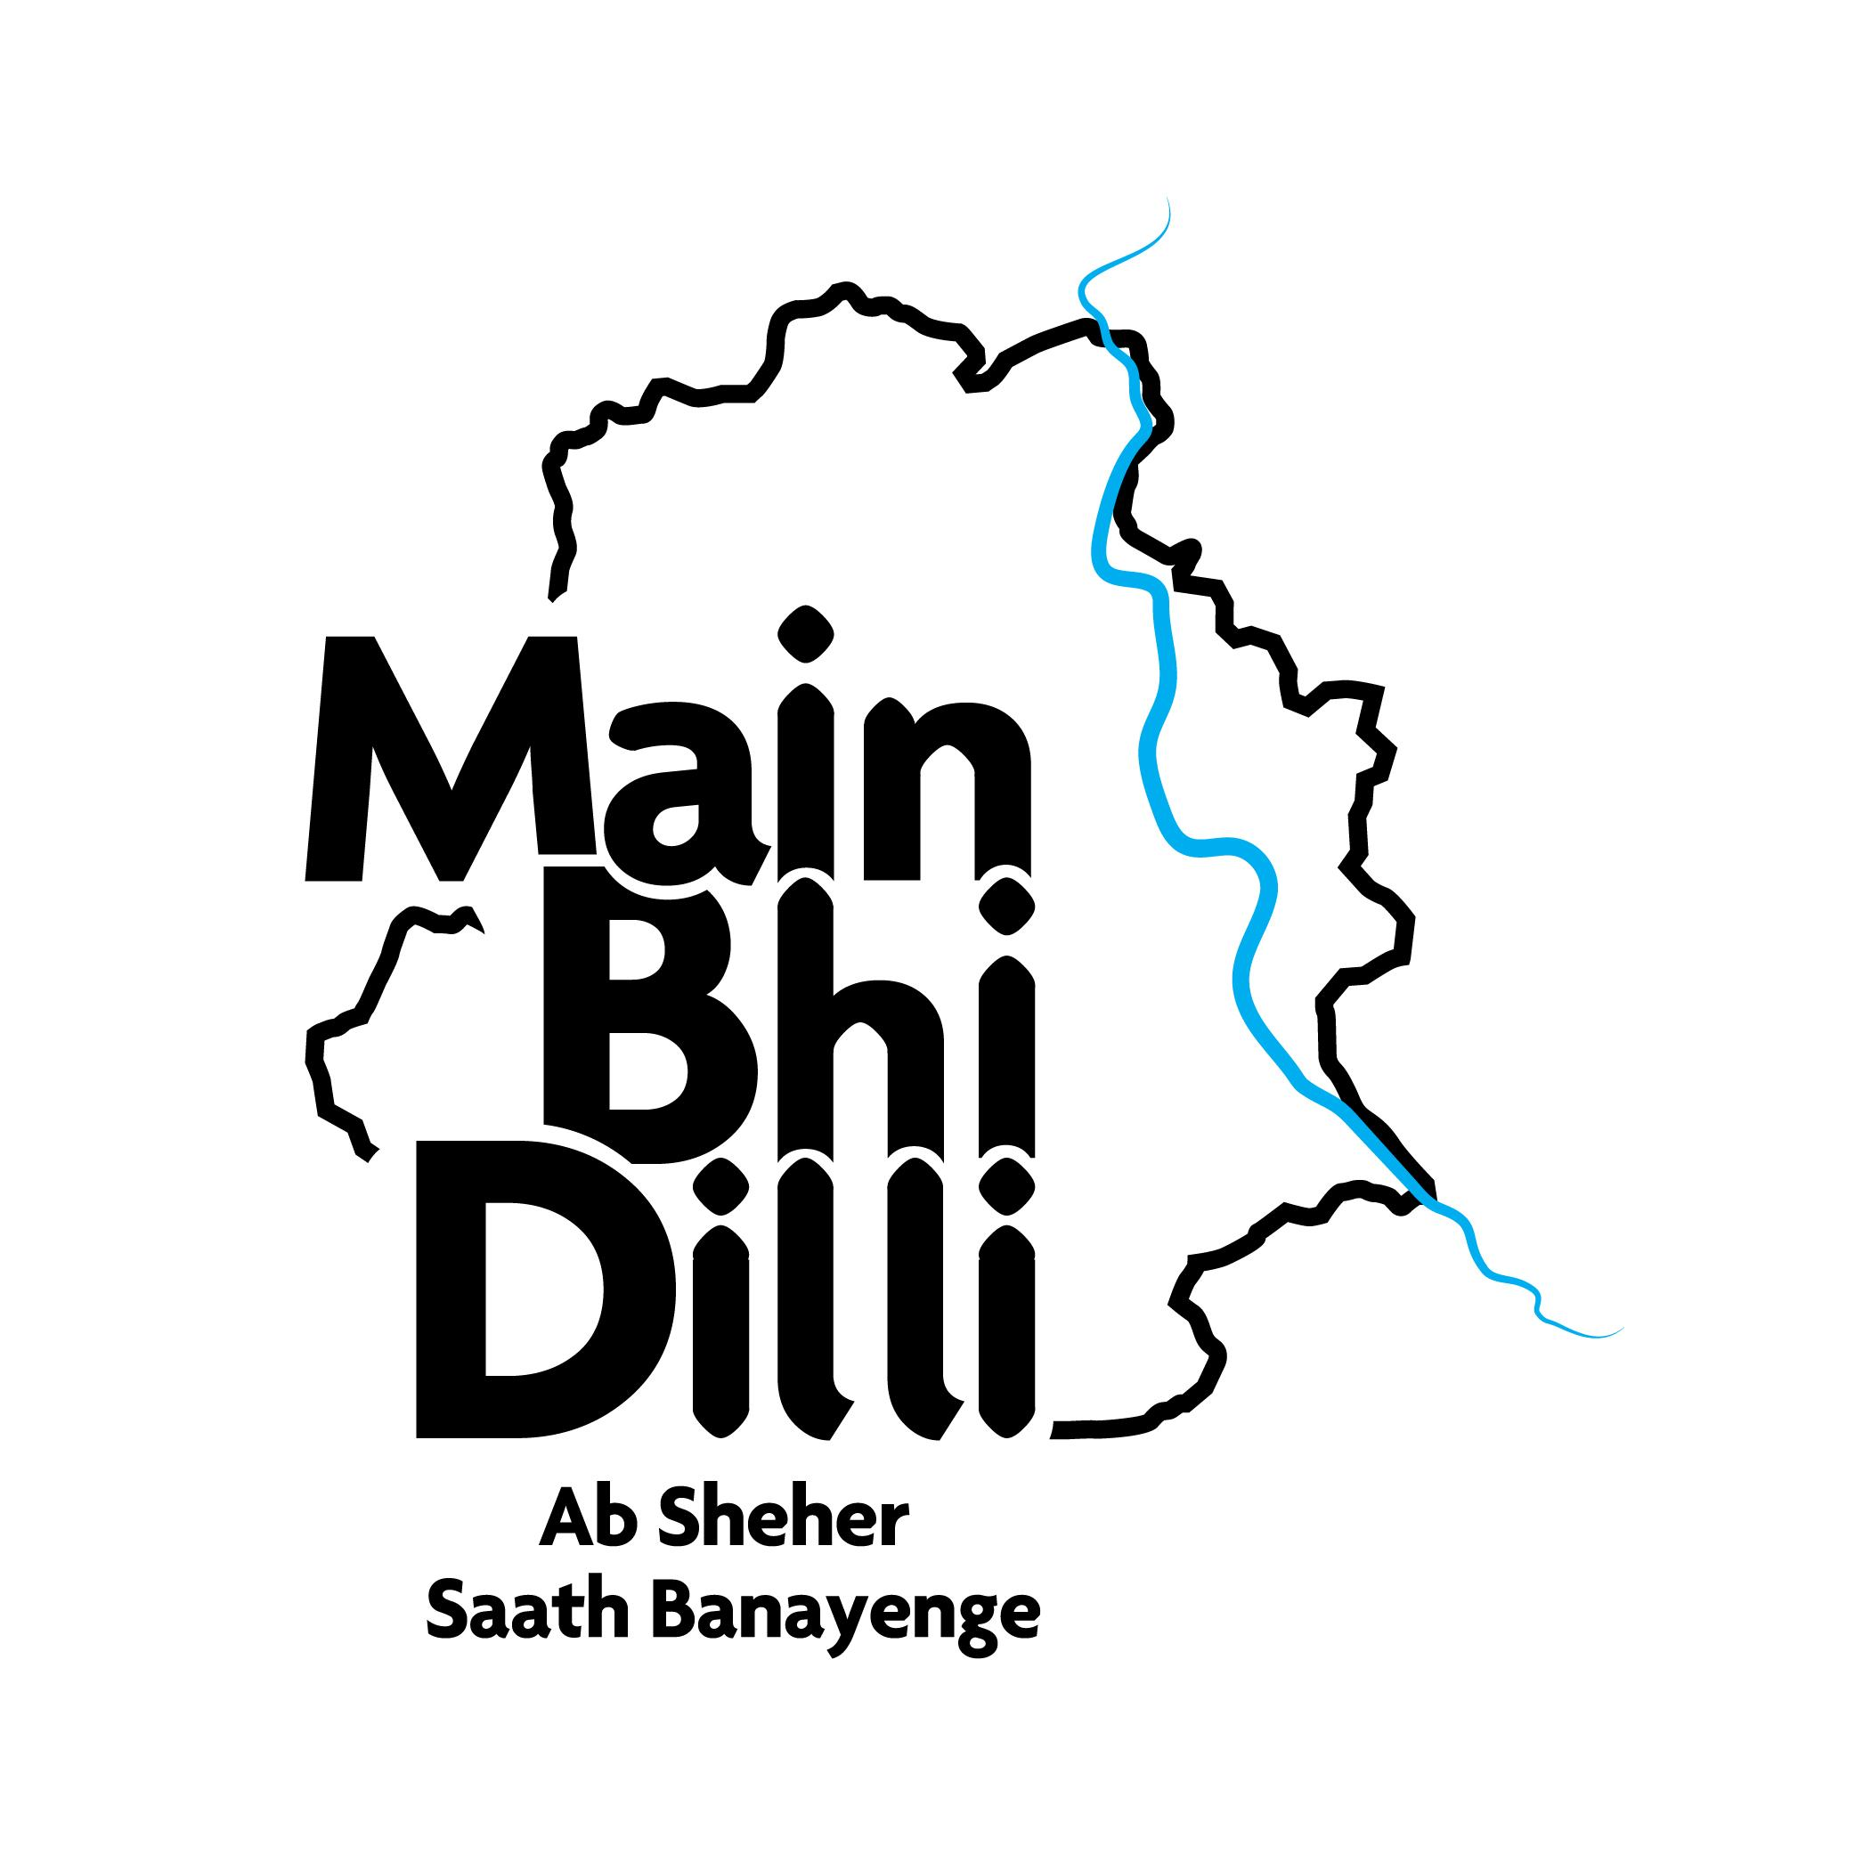

STATEMENT AGAINST FORCED EVICTIONS IN DELHI
18 September 2020

The Main Bhi Dilli Campaign writes today to extend our unequivocal support to the nearly 2.5 lakh residents of Delhi who are facing the risk of eviction and loss of their homes. We condemn the order by the Supreme Court of India in M.C. Mehta v Union of India & Ors. (Writ Petition No. 13029/1985) which summarily demands forced evictions of long-established communities on lands entrusted to the Railways in Delhi. We urge the Court to urgently reconsider this injunction in light of the grave consequences its execution is likely to result in. Passed in a long pending case on waste management in the city, the order will have devastating consequences on the lives, livelihood, dignity and rights of nearly 50,000 households. It also comes at a time when the city is barely coping with the assault of the COVID-19 pandemic and will expose marginalised communities to health risks that further compound the threat to their homes, assets and livelihoods.

The Main Bhi Dilli Campaign is a collective of people’s organisations and individuals aiming to make Delhi into a more inclusive and sustainable city. Our focus is to participate in the urban planning process especially with regard to the Delhi Master Plan, to make it more transparent and include the voices of the most marginalized citizens who are always left out. We want a city that assures dignity of life and work for all citizens.

Our practice and research on housing in the city has shown us that:

- There is a clear lack of adequate, affordable, and ‘legal’ housing in Delhi.
- Where it is legal and adequate, the market ensures it is unaffordable for a majority of residents. Where it is legal and affordable, it is neglected in services and infrastructure or located in the far periphery of the city.
- We recognise that for housing to be viable, it has to be accessible in terms of livelihood opportunities. People settle in a place because it makes economic sense for them to do so. There are huge humanitarian and gender costs to evictions.
- There has been a systematic state failure in providing affordable housing in the city. The projected numbers for EWS and LIG housing in the previous three master plans were never met or completed. Public authorities have demolished more houses than they have built.
- It is precisely because of this lack of decent viable housing that people have had to self-build and provide for themselves. Informal settlements made by people are the solution. Removing them as encroachments is not an answer.

In the light of the above, it is clear that the recent order instead of addressing these lacunae in the housing stock is criminalising citizens. Those who have always been denied a voice in determining urban planning priorities are once again being affected in this moment of crisis.

Thus we stand with The Railway Basti Jan Sangharsh Morcha and support the National Day of Protest on 18th September, 2020. We endorse their demands that:

- Residents be consulted in the making of any plan that affects their homes and livelihoods and no plan proceed without their consent
- That the plan prioritise in-situ upgradation, as per the lines of the promise of Jahan Jhuggi Vahan Makaan made by both Central and State Governments.
- That the plan treat resettlement only as a last resort and offer it to those who consent to it instead of making it mandatory or the only option.
- That no resettlement can take place without complete social and civic infrastructure being in place at the new site and a transportation plan in place beforehand.
- That the plan adheres to DUSIB 2015 policy strictly and offers no resettlement options that are beyond 5km of the original settlement.
- That no one is denied access to resettlement for lack of financial resources
- That the Railways assures that, even after four weeks, no forced eviction in violation of housing rights and government policy will take place and no action shall be undertaken until all procedures of surveying, taking of consent and finalizing of in-situ or resettlement options are complete.
- That the Railways assures that no coercive action will take place regardless of the circumstances, during the COVID -19 pandemic and while the NDMA and the Epidemics Act are in force.

The Main Bhi Dilli Campaign further urges the various government agencies concerned with urban planning to ensure the following in the short and long term -

- Reservation of land for affordable housing- This should include both new areas, and existing areas with informal settlements which should be recognised as part of available housing stock and improved.
- Blanket no eviction policy- All existing settlements to be recognised through granting of tenure rights and infrastructure upgradation wherever viable
- Comprehensive resettlement only as last resort- This should be only when location is not viable and determined through community participation. The new sites must be fully serviced and approved by the community.
- Diversify housing types- The city’s housing plans must include rental, worker hostel, migrant housing, student housing, housing for nonmarital households etc.
- Universal access to basic services

The Right to Housing is non-negotiable and the Main Bhi Dilli campaign underlines our commitment to all people in their struggle for decent housing in our city of Delhi and other cities across the world.

